E-PROJECT

SFM GIFT SHOP

**Submitted To**

[eprojects@aptech](mailto:eprojects@aptech.ac.in).com

**Group Members**

ATEEQ UR RAHMAN

&

KHUAJA TALA



**TABLE OF CONTENTS**

ACNOWLEDGEMENT …………………………………………………………………...3

SNOPYSIS …………………………………………………………………………………3

ANALYSIS ………………………………………………………………………………...4

PROBLEM STATEMENT …………………………………………………………………5

FLOW CHART …………………………………………………………………………….6

SUBMISSION CHEKLIST ……………………………………………………………….7

USER GUAID ………………………………………………………………………………8

DEVELOPER GUIDE………………………………………………………………………19

ACNOWLEDGEMENT

First of all, I thank full to my teacher and APTECH Pakistan.

We are proud to present to you this project which was assigned to our group, a website for gift shop. This website was made by a group of 2 people, each one contributing equal amounts of effort and succeeding. This would not have been possible without the hard work of our dear teacher.

E-PROJECT SNOPYSIS

The website is about buying and selling and online shopping its guide user in shopping and selecting the items we give the easy way off online shopping we a button for selecting the item for add to cart when user click this button so the selected item adds into cart with collectable price.

ANALYSIS

|  |  |  |  |  |  |
| --- | --- | --- | --- | --- | --- |
| No. | Task | Actual Date Start | Actual Days | Task Mates  Name | Status |
| 1 | Case Study | 8th March 2019 | 3 | K.Talal  & Ateeq | completed |
| 2 | Designing | 11th march 2019 | 4 | Ateeq  & K. Talal | completed |
| 3 | Interface  Designing | 15th March 2019 | 7 | Khuaja talal | completed |
| 4 | Material  Searching | 22th March 2019 | 2 | K.Talal  & Ateeq | completed |
| 5 | Testing/publishing | 24th March 2019 | 2 | Zain Ul Abideen | completed |
| 6 | Documentation  ` | 26th March 2019 | 2 | Ateeq ur rehman | completed |

PROBLEM STATEMENT

SFM GIFT SHOP is selling various types of Gift Items. The company advertises by distributing the pamphlets, advertising on television and so on. Due to rapid development in internet field, the company decides to launch a website where people will get all the information about the various products available with them easily.

CUSTOMER REQUIREMENTS

The Web site is to be created based on the following requirements.

1. The Home Page should be created with sections, graphics and with a suitable logo.
2. Home Page should contain details of Gift Items with suitable images.
3. The site should display a menu which will contain the options for brief introduction about the various gift items available, location of the shop and any other information if required.
4. The information about products should be presented in two ways:
   * + - 1. Information should be available category wise, wherein user can click on a particular category and should be able to view all the products related to the category available with complete information. Eg. Category can be “Mugs”, “Cards”, Bracelets” etc. with suitable sub-categories been defined.
         2. Information should be categorized according to the brand names of the products like if a User wants to see only “Hallmark” products or any other company’s products then he/she can click on a Link/button/menu etc and can see only that Brand products.
5. When a user selects any particular brand, a list of products for that brand will be displayed
6. A brief summary of features of individual products should be displayed on the Web Page along with the product but detailed Features should be stored in Individual Word documents which can be downloaded or viewed by the User who wishes to see the same.
7. The user should also be able to compare the various products of different as well as similar brands.
8. There should be a “Contact Us” page which will have the Address of the Company which is as follows and the mail address which when clicked will invoke the local mail client from where they can send an email.

FLOW CHART

**SFM GIFT SHOP**

HOME

ABOUT US

COMPAIRE

CONTECT

CATEGORIESS

BRANDS

RADO

Toys

GUCCI

Collectibles

Perfumes

Jewelry

BORJAN

Mugs Handicrafts

Accessories

Sports

# 

# Submission Checklist

|  |  |  |  |
| --- | --- | --- | --- |
| **S.NO** | **LIST OF ITEMS** | **Remarks** | **COMMENTS** |
| 1. | Do All Pages Linked together | **Yes** | On Self Target |
| 2. | All Hyperlinks working | **Yes** | On same or Different Div. |
| 3. | Page Colors As Per Common Guidelines | **Yes** |  |
| 4. | Site Browser Compatible | **Yes** | ALL SITES |
| 5. | Image Slicing | **Yes** | Using Adobe Photoshop, |
| 6. | Feedback Form Included | **Yes** |  |
| 7. | Project Zip File | **Yes** | Created using WinRAR |

USER GUAID

SEARCH BAR

HOME

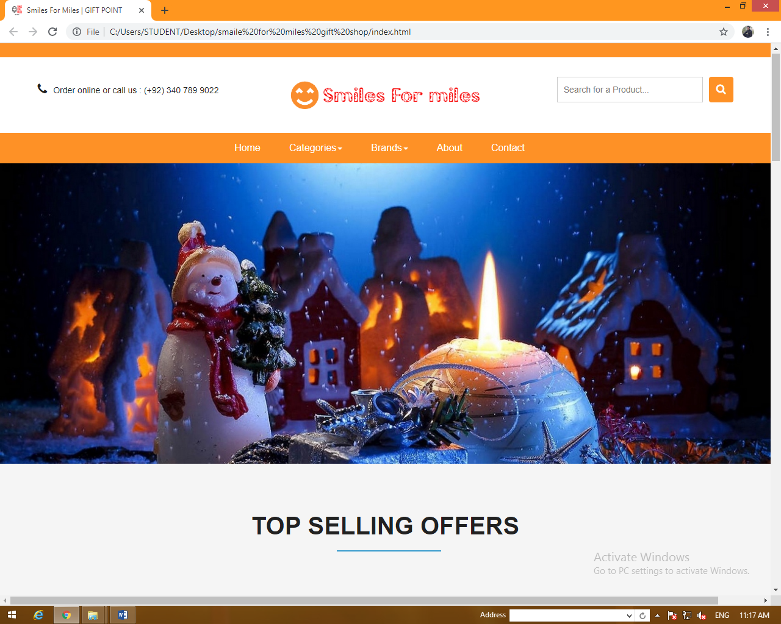

NAVIGATION BAR

LOGO

AUTO SLAIDER

ADVERTISED OFFERS BUTTON

OFFER BUTTON

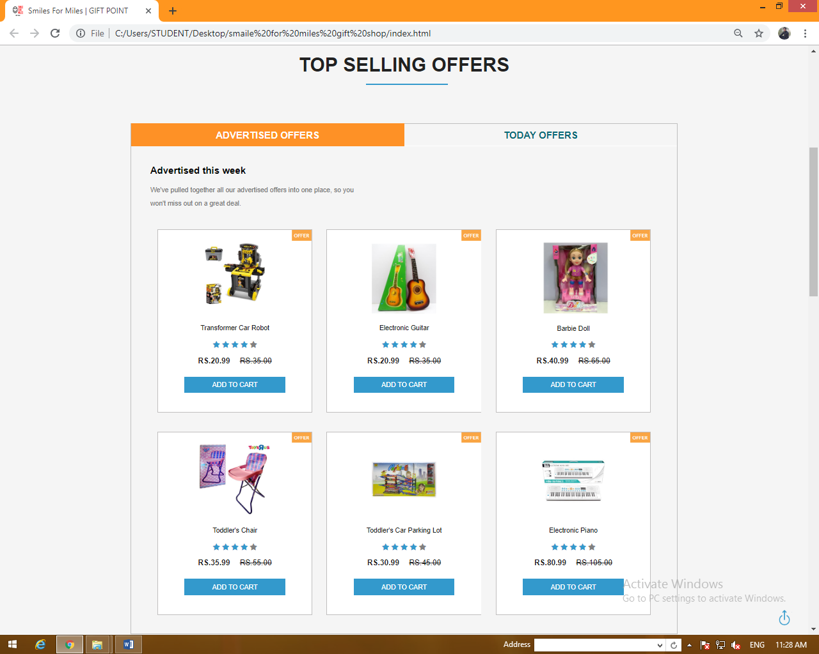

ADD TO CART BUTTON

TODAY OFFERS BUTTON

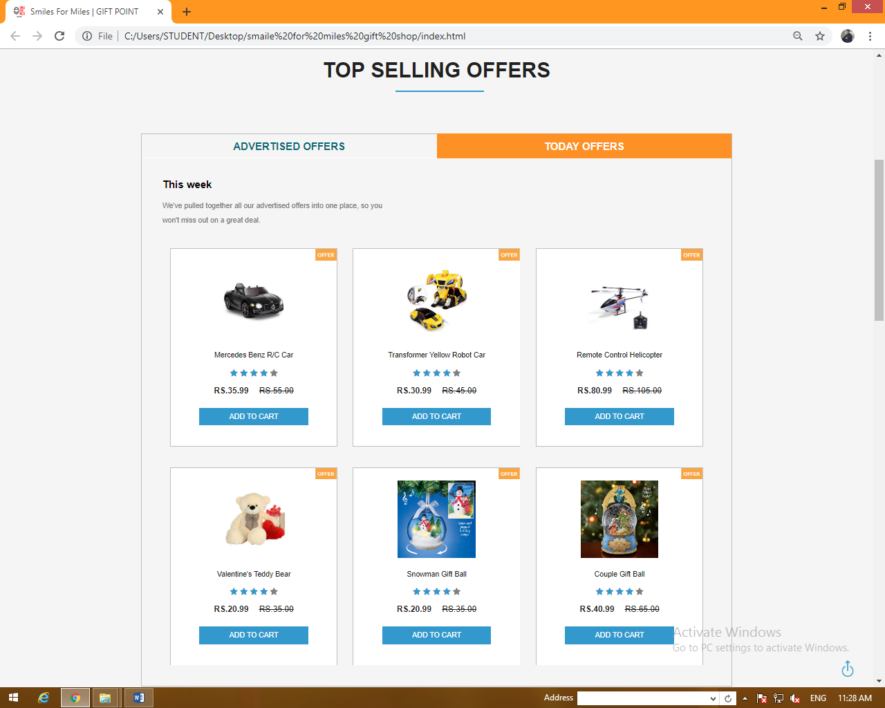

SLAIDER

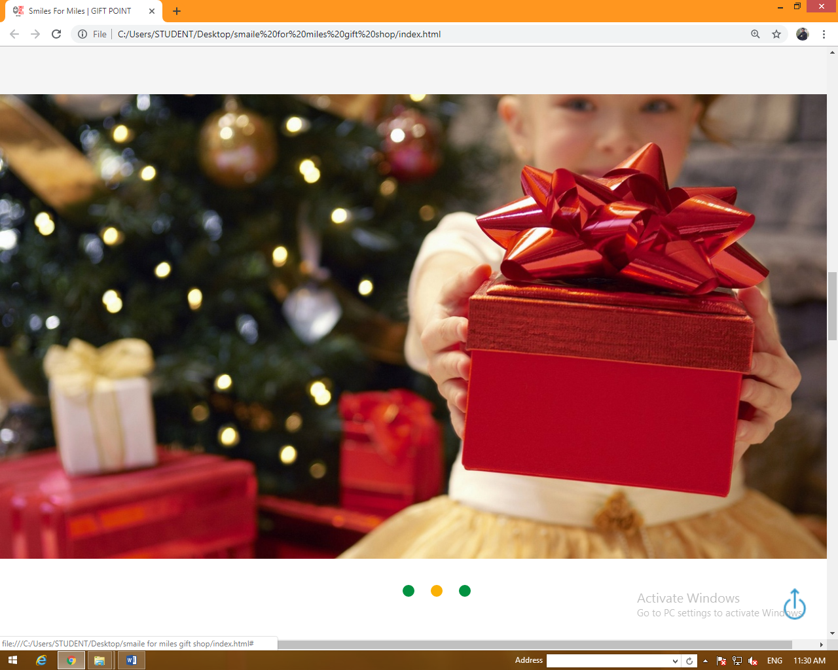

CONVERT BUTTON

BRANDS PAGE

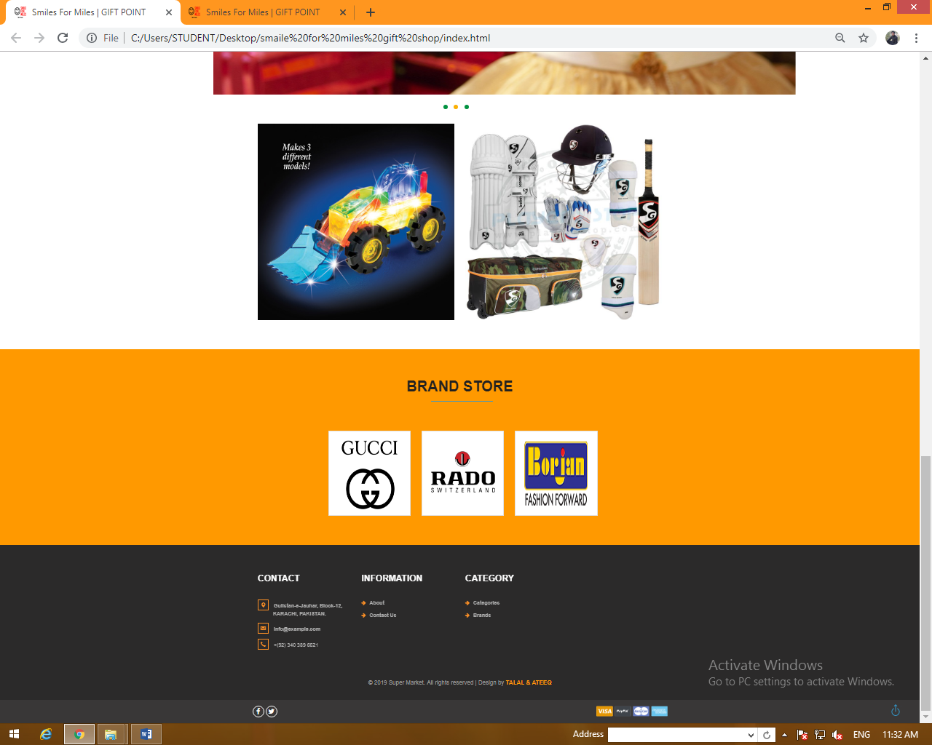

FOOTER

SOCIAL ICONS

UP TO BUTTON

ABOUT US

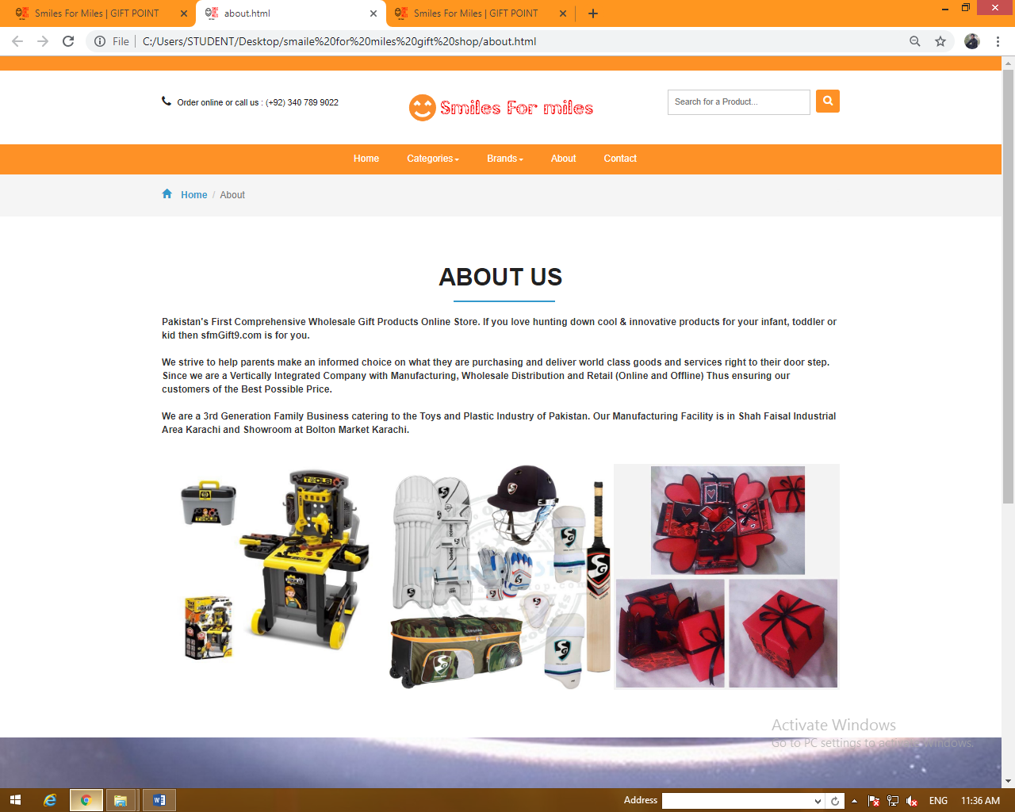

ABOUT US PAGE

CONTACT US

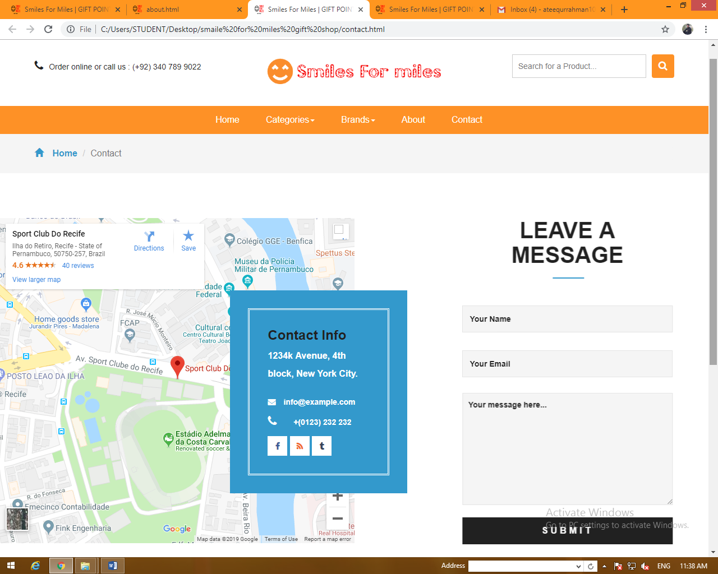

GOOGLE MAP

SUBMIT BUTTON

CONTACT INFORMATION

CONTACT FORM

CATEGORIES

CATEGORIES NAM

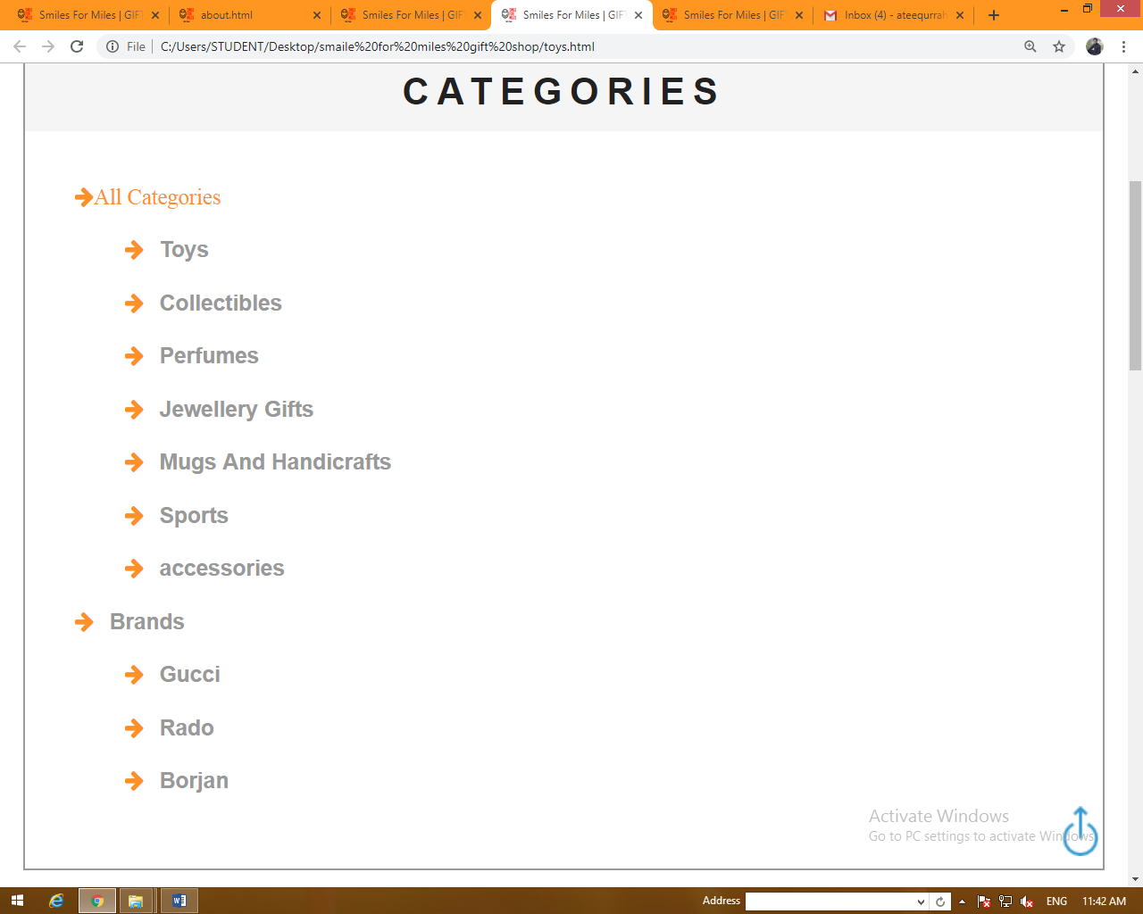

BRANDS NAM

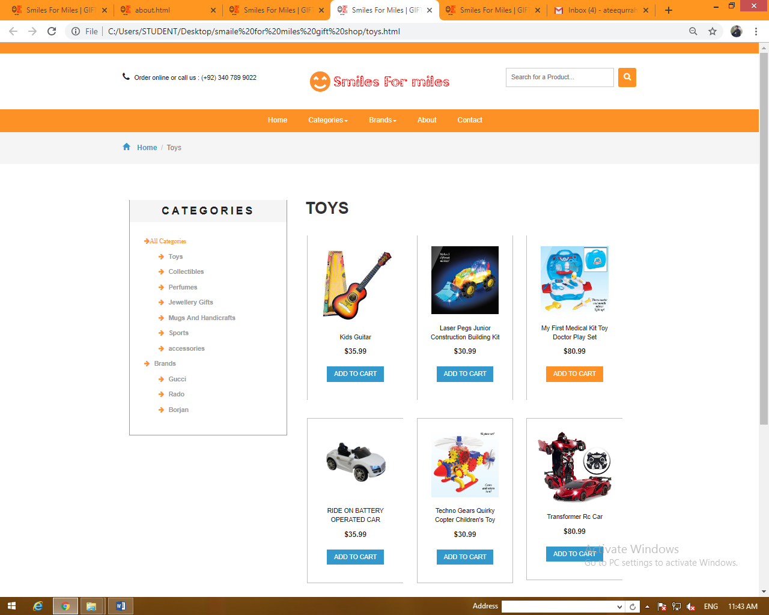

CATEGORIES ITEMS

BRANDS

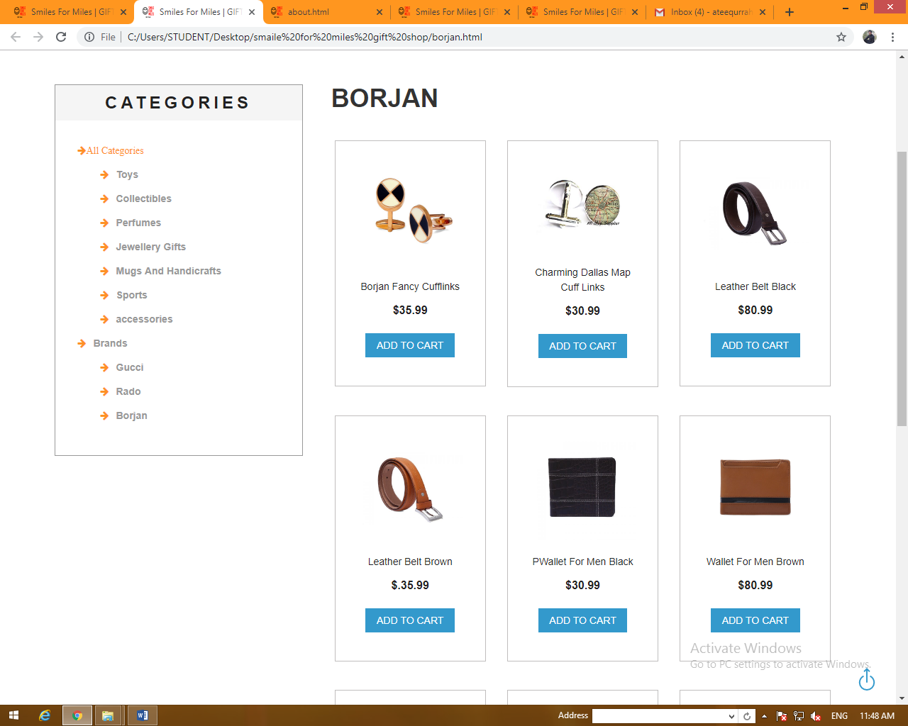

BRANDS ITEMS

DEDCRIPTION

SLECTED ITEM IMAG

ITEM NAM

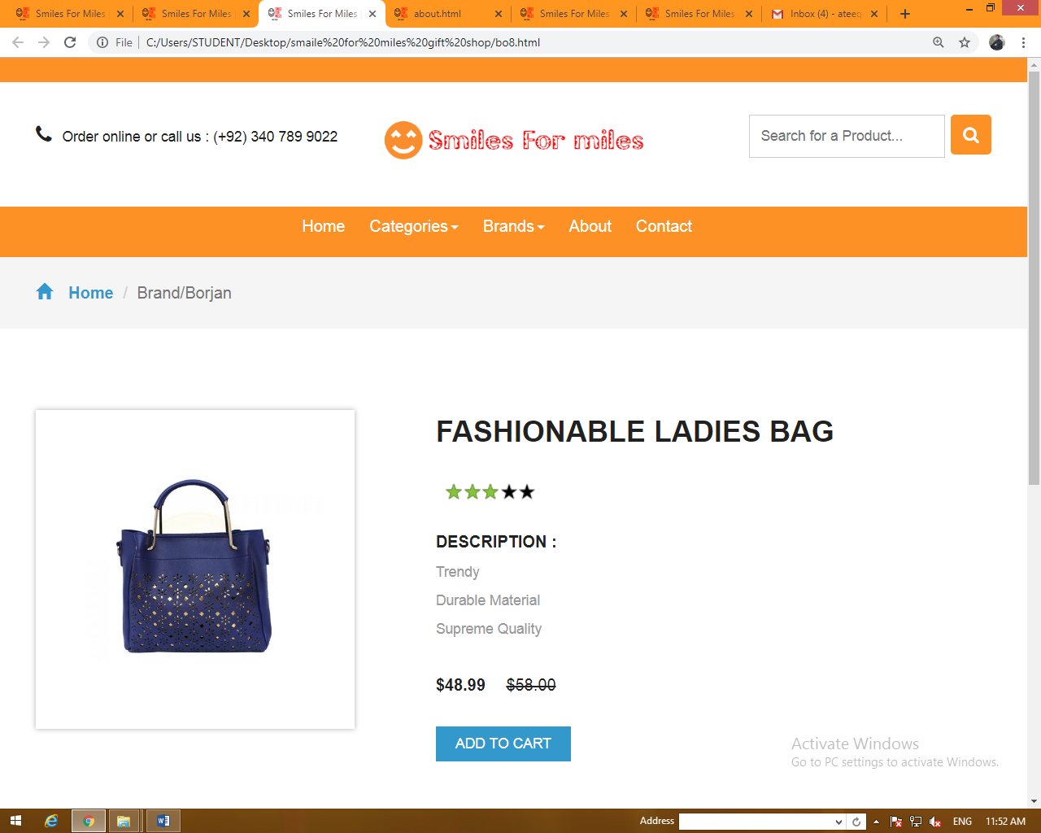

RATTING

ADD TO CART BUTTON

ITEM DESCRIPTION

**DEVELOPER GUIDE**

HOME PAGE

This is our home page

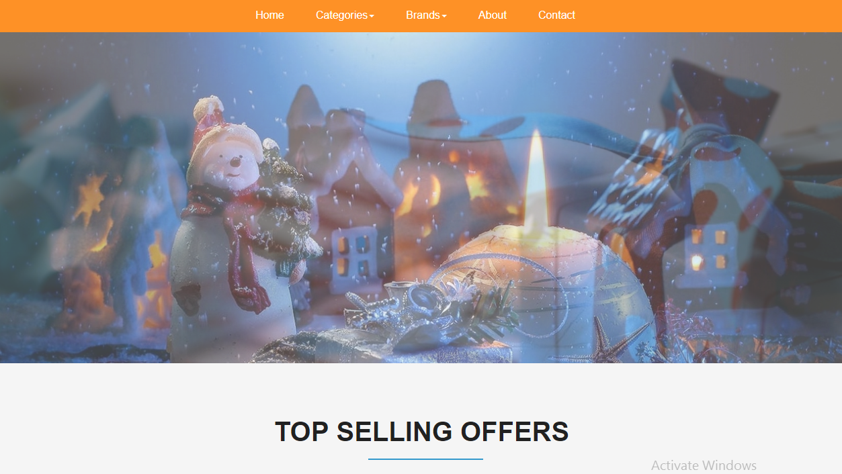

NAVIGATION BAR



* Home
* Categories
* Brands
* About us
* Contact us

We have make a slider in div at Home Page.



Then we create a man div of advertising and created multiple divs in this div first page is about weekly offer and second page is about today’s offer .in these pages when we click on any image so open the disruption item and we create a div in button type of add to cart when we click there so the selected item adds in cart.

And we create offers button in all items off home page

OFFERS OF THIS WEEK;

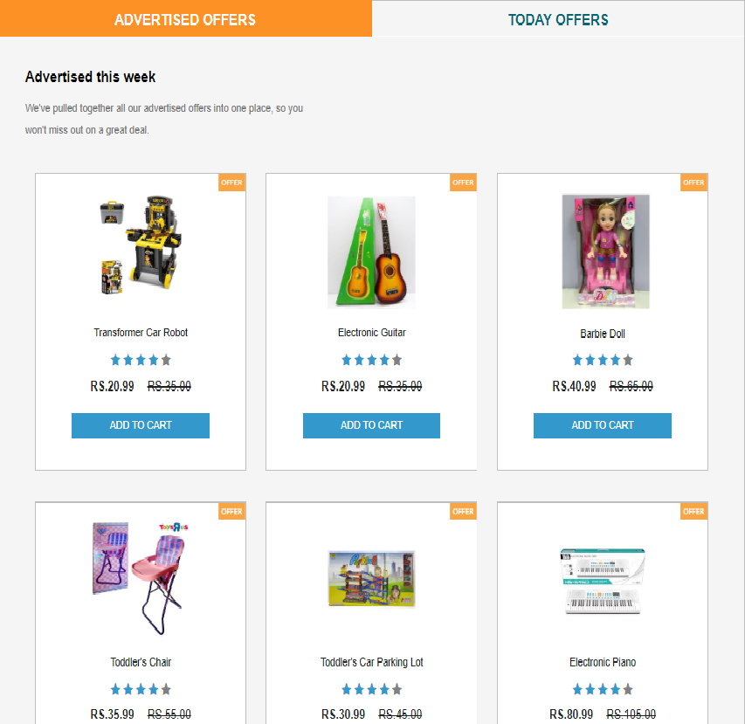

Today’s offers page:

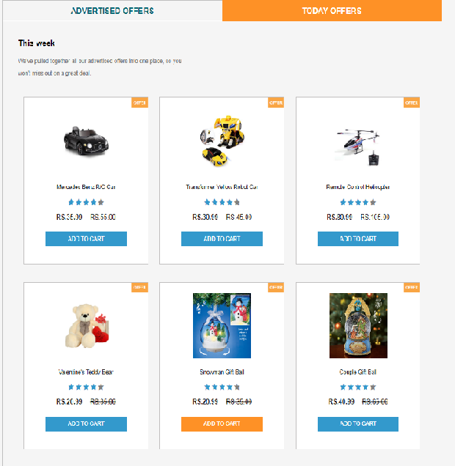

After that we create a div with links in the name off brands page. When we clock on any brand so we go the brands page.



FOOTER

In this section we create social media icons when user click to icon so open social media in next page. And we give the address and maps links.

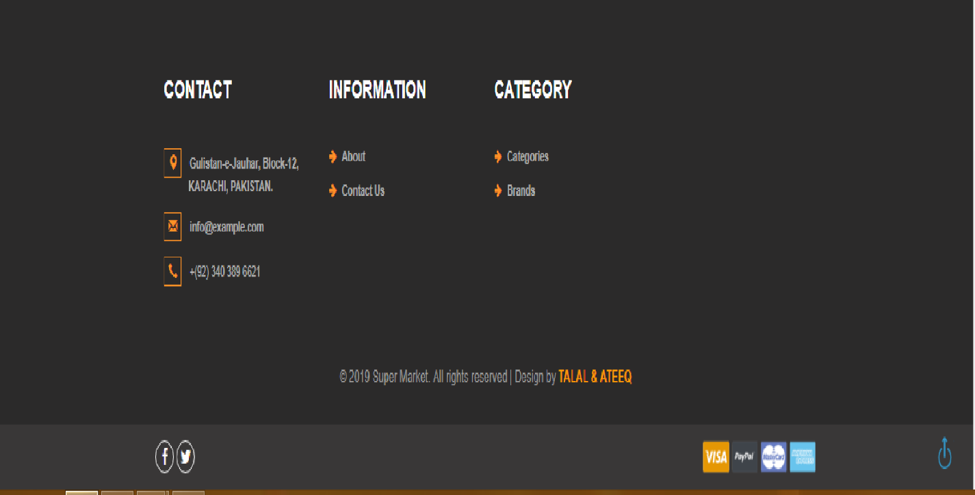

ABOUT US PAGE

in this page we create divs with descriptions in this page we give our services in footer we give same items.

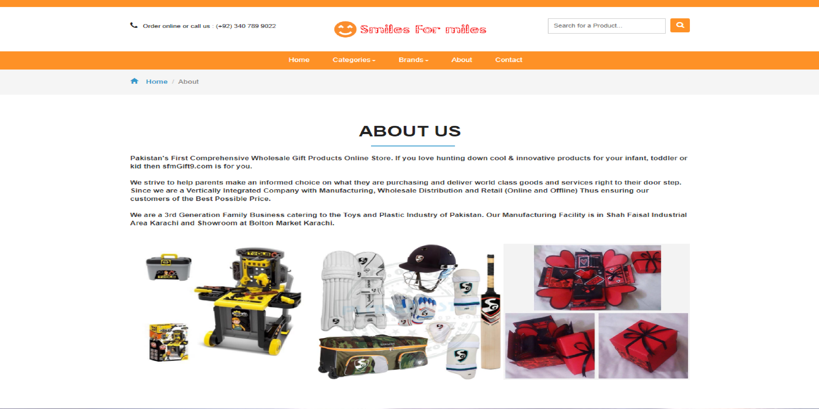

CONTACT US PAGE

In this page we give our shop location with google maps link and we create a form about contact. And we also create a div for contact information.

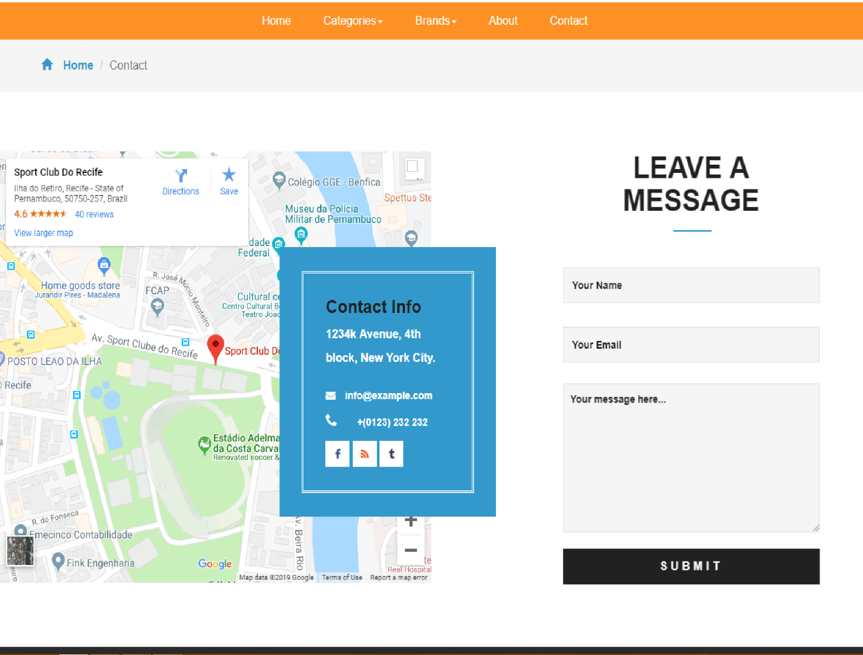

CAREGORIES

In categories we select seven items. wen user click on any item so go to main page off this and in this page we give descriptions of items.

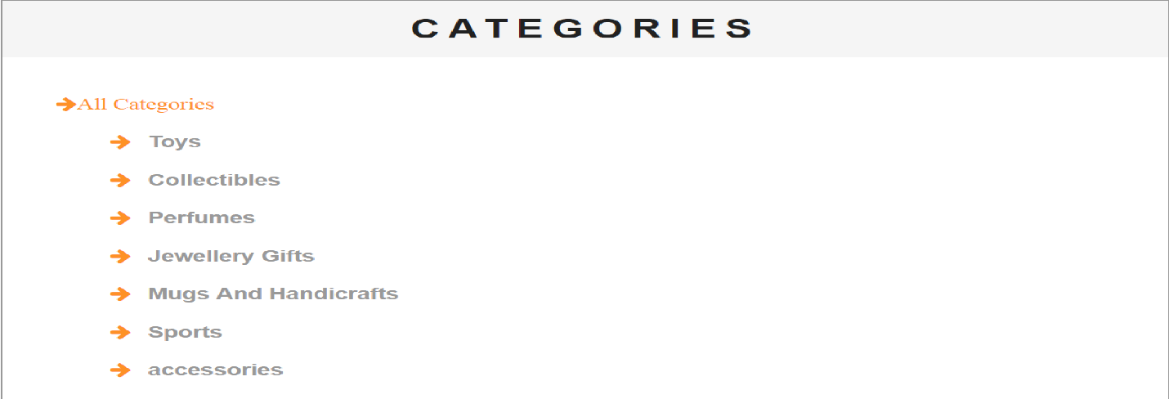

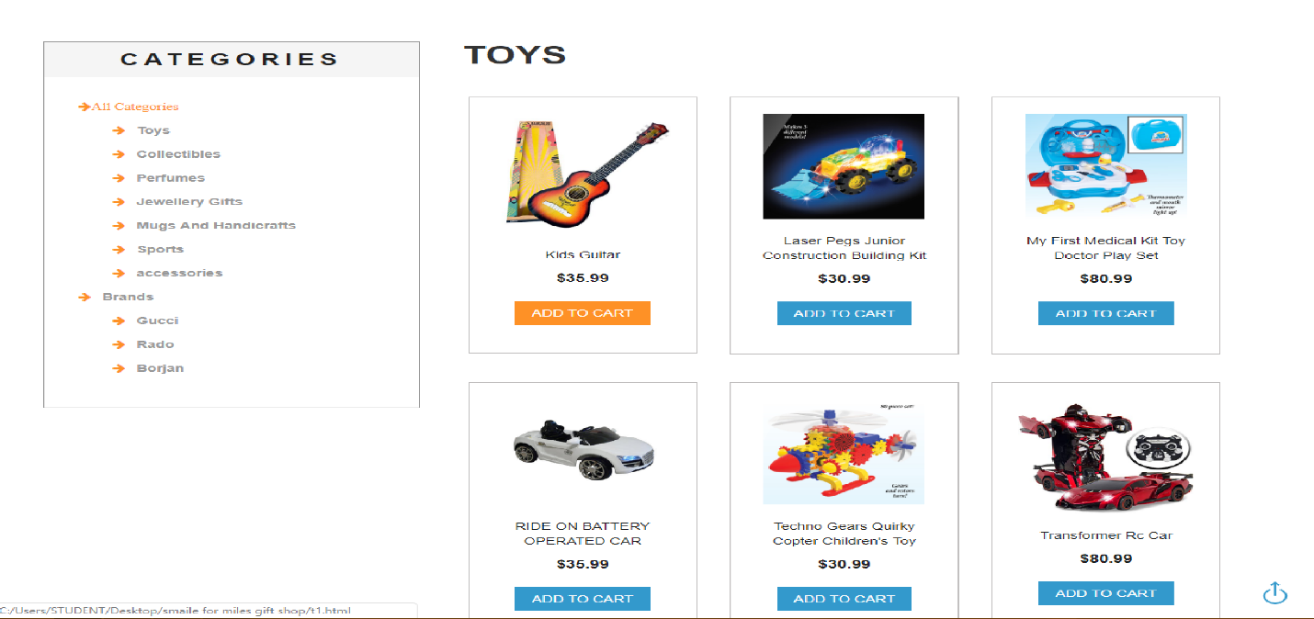

BRANDS

in this page we select three brands RADO, BORJAN, GUCCI we create pages off these brands we user click on any brand so open the brand page.

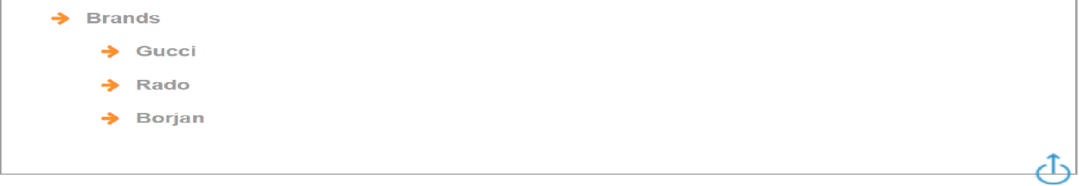

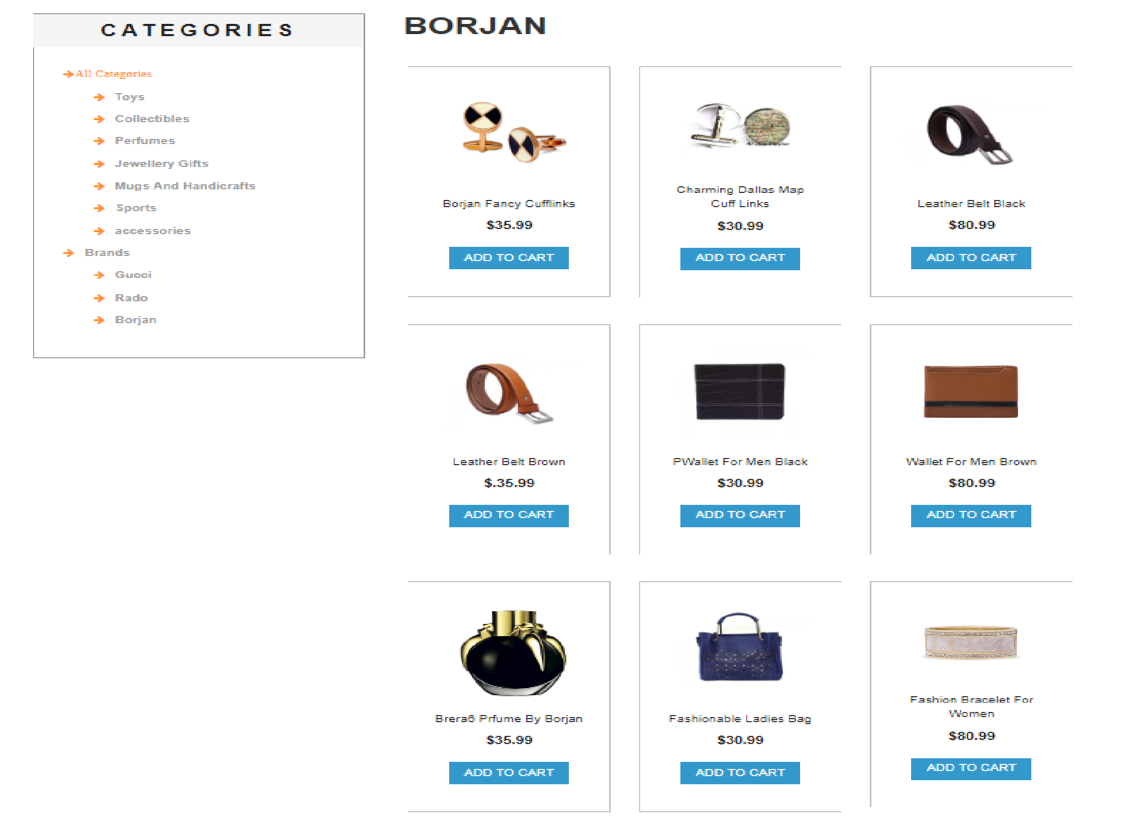

DISCRIPTIONS

We create a page in the name off DISCRIPTIONS in this page We give give description off items wen user click on any item so the description page is open with details.

